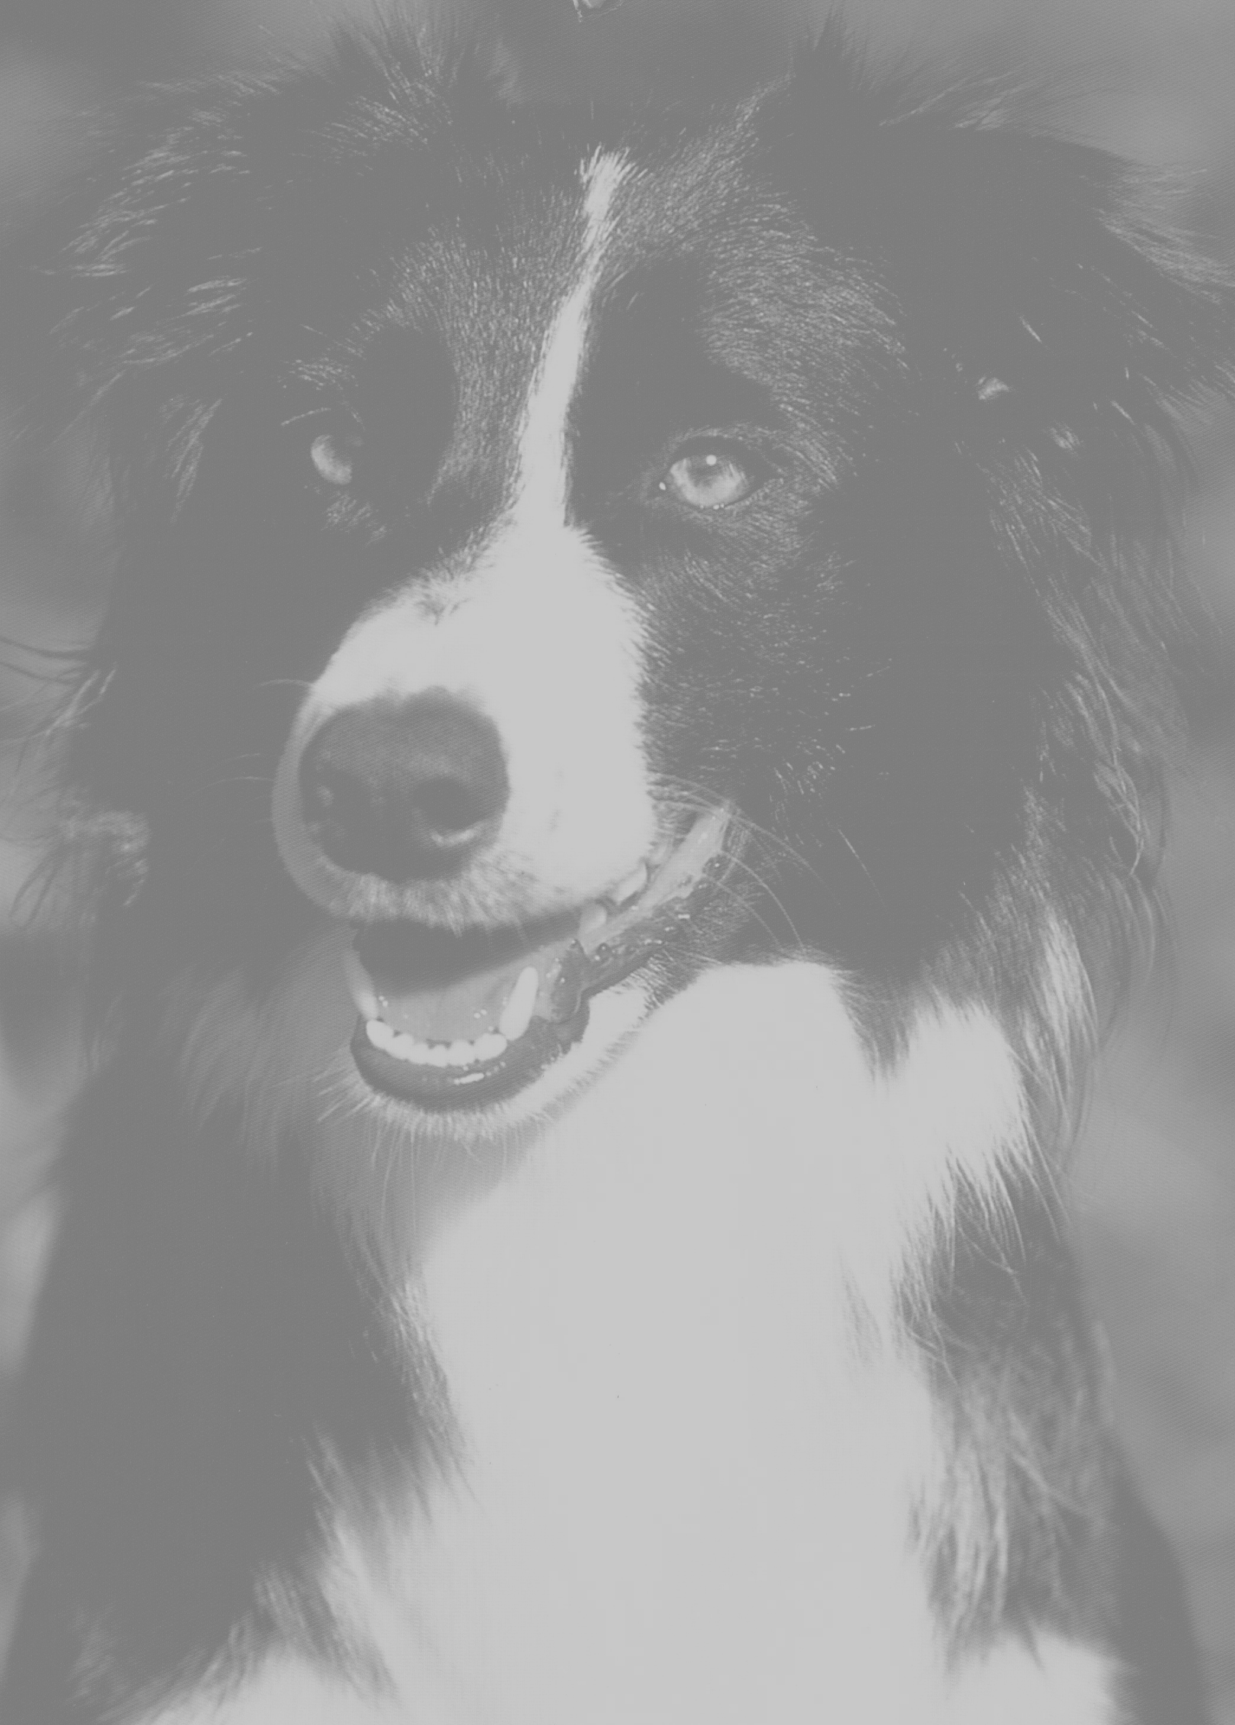

HELPING YOU

RUN A TRIAL WITH

QUEENSLAND WORKING CATTLE

DOG TRIAL ASSN. INC
2023-24

CONTACTS:
President: Dave Steel steelfamily1@hotmail.com 0437 844078
Secretary: Cassie Donovan kratzmanncassie@outlook.com 0439 461629
Treasurer: Elizabeth Hughes behugheselectra@gmail.com 0438 339575
6 Back Electra Road, Electra Qld 4670
Newsletter: Chris Whitney, PO Box 1638, Charters Towers 4820 47 871576
Dog Registrar-Steele Cannell steelecannell@gmail.com 0428 583260
Points Scorer- Marcia Berrie tmberrie@icloud.com 0436 023275
Web Master& Facebook- Cassie Donovan kratzmanncassie@outlook.com 0439 461629
Publicity Officer: Wyatt Judd wyattj96@outlook.com 0409 365466
Sponsorship: Samantha Connolly samconnolly11@hotmail.com 0429 292057
Chairman Judges Panel: Paul Wroe 0488 682491
Web Page: www.qwcdtai.com Facebook: www.facebook.com/QWCDTAI

When setting a date for a new trial, contact the Secretary- Cassie Donovan, to make sure that your trial date does not clash with any other organised trial.
All on-going committees please advise the Secretary or President early September of your trial date for the following year. Please state: Venue &Date of Trial
Contacts + phone numbers
- Once all the dates, venue etc are decided a list will go to the newsletter editor, Chris Whitney, so that your trial can be advertised in the Christmas addition of the newsletter calendar for the following year.
If you produce a programme/flyer you may also include: - (Template available on webpage)
Entry fees (max. of 10% of first prize or $15.00, incl GST & all levies, whichever is lowest)
Trials being run e.g. Open & Novice or Novice/Maiden combined
Prize money (optional as calculation may depend on number of nominations)
Facilities available (food, accommodation etc)

Entry closing date-optional (usually one week prior to trial)
Mudmap if required
:Competitors must be financial members of QWCDTA Inc. or pay a $10.00 fee to QWCDTAI to compete at an affiliated trial.
:Product and Business advertisement for our major sponsor- Ridley AgriProducts are sponsoring “Cobber” dogfood for all trials. Please include them in your advertising/ promotion.
:If you have limited time available (e.g one day trial only) please inform competitors at time of placing nominations that the number of dogs per handler may have to be restricted.
:if you want competitors to give Dog names & running order at time of nomination so that details are printed on the draw sheet. (for Championship programme etc).

- PRIZEMONEY etc: Calculated on the 10% rule for 1st place (e.g $15 nom = $150, $10 nom = $100 with 2-6th downward in proportion). Open & Novice placings are awarded to 6th place .
A trophy for the winner (if possible), prizemoney & ribbons for 1st-6th would be appreciated.
Maiden placings, trophy,prizemoney &ribbons etc are at the trial committees discretion but would be appreciated to 6th place if possible. (See also-separate section for Championships re placings etc)
Prizemoney break-up is up to committees but some guidance has been requested. These amounts may be adjusted as per the amount of income received from nominations & sponsorship and the expenses incurred. (We do expect that the reason you are running the trial is to make some money for your organisation while hopefully giving as much back as you can to the triallers who support you.)
These expenses include: Prizemoney, Ribbons/Trophies, Affiliation fee, Insurance cover, Cattle cartage, Hire of grounds & equipment, Judges fees & catering for Judge & helpers.

Prizemoney Suggestions: (at bottom-number of nominations needed to cover prizemoney only)
1st $350 $250 $200 $200 $150 $100
2nd $200 $150 $150 $150 $100 $ 80
3rd $150 $120 $120 $100 $ 80 $ 60
4th $100 $ 80 $100 $ 80 $ 60 $ 40
5th $ 80 $ 60 $ 80 $ 60 $ 40 $ 20
6th $ 60 $ 40 $ 60 $ 40 $ 20 $ 10
Total $940 $700 $710 $630 $450 $310
62.6 noms @$15 46.6 noms@$15 47.3 noms@$15 42 noms@$15 30 noms @$15 31 noms @$10
58.3 noms @$12 59.1 noms@$12 52.5 noms@ $12 45 noms @$10
Your other expenses (& expected profit) would need to be covered by the nomination excess (i.e the number of noms over &above the number listed above), sponsorship & canteen.
INCOME from NOMINATIONS & Sponsorship etc will dictate what you can allocate as will the expenses.

- INSURANCE: Most Show Societies etc are covered under their own policy, if you do not have this please contact the Treasurer so that arrangements can be made. A fee of $50 applies. Please also write to the Secretary stating that you wish to be covered under the Association Public Liability Insurance Policy include date, venue etc. Committees wishing to use the association Insurance cover must have a minimum of two financial QWCDTAI members on their committee. All finances (income & expenses) may be handled through QWCDTAI or the local branch bank if association insurance cover is used and the Committee does not have a bank account. Committees may open a bank account & handle their own finances if they wish to (passed at meeting 28th April 2018)

- AFFILIATION FEE: $50.00 Affiliation fee must be paid to the Treasurer one (1) month prior to the trial (an account will be sent to you). Points for Dog of the Year are allocated from affiliated trials.

- You will also require:- A Scorekeeper & a Timekeeper.
Full Scoresheets & results (incl. Number of Open or Novice dogs in each trial) are sent to the Points Scorer as soon as possible please. (for Records & Dog of the Year points allocation). Results should also be sent to the Webmaster as well as photos for Facebook asap. Also send results & any items of interest incl. photos to Chris Whitney for Newsletter.
A commentator is most welcome to announce competitors, scores etc.

6. JUDGES:
Judges must be used from the current Judges list & must be current financial members of QWCDTAI to judge at an affiliated trial. Please contact the Chairman of Judges Panel, Paul Wroe 0488 682491 for names of available judges (i.e. have not judged yet) so that all judges are used before having to judge a second time. Runs by the calendar year.
Payment to Judge is normally $1 per dog on 1st round numbers for Open & Novice/Maiden trials.
The judge is to be seated, independently from all spectators, competitors and committee members.
This is the responsibility of the organising committee.

7. SPONSORSHIP : Ridley & QWCDTAI will sponsor Cobber dogfood for each trial venue to 30/06/27. Amounts available will be advised when available-2023 $650) on a cover letter, you will need to organise how much you will get for the money & where you will pick up from. QWCDTAI will pay on invoice before delivery or will reimburse committee on receipt of suppliers invoice.
If you are offered sponsored dogfood please ask to have “Cobber” as they are the sole sponsor/supplier of dogfood for QWCDTAI in 2022/27. A Thank you to Ridley for their support incl photos from trial etc would be appreciated:
Attn: Sponsorship to Kellie Savage Kellie.Savage@ridley.com.au
RUNNING THE TRIAL.
TRIAL COURSE: Diagrams attached
THE COURSE: To be set up by the organising committee (consult judge or experienced triallers if necessary) & must comply with either Pattern 1 or Pattern 2. The variable size of the hold & distance to place the handlers peg from the obstacle are noted on the pattern to allow for flexibility dependant on the cattle. The Organising committee must be consulted before course is changed.

DRAW: A draw of all handlers will be made before the trial (i.e.1st run/ round/rotation), handlers will compete in this order for the whole of the trial (2nd run etc and following runs etc) until all handlers have competed once with all their dogs. If for some reason a handler misses their turn in the draw, they will go to the very end of that particular round (not the end of the trial).
If desired, a four round/rotation draw may be used. Handlers with more than 4 dogs will have extra dogs in a round/rotation i.e with 5 dogs they would have 2 in 1st round & 1 in each of the others, with 6 dogs they would have 2 dogs in the 1st & 2nd round & then 1 in each of the other 2 rounds etc. This way there is no handler at the end running one dog after the other. Contact Elizabeth Hughes for assistance with this draw.
If dog names have been requested & submitted & a dog is scratched, a substitute dog (that is not already nominated) may run in that draw position. If there is no substitute, all remaining dogs for that handler move up a rotation. This same draw order is carried through to the FINAL (no separate finals draw).

FINALS: There must be a final for the Open & Novice trials (Maiden optional) : - Minimum of the top scoring ten or 10% of entries (whichever is higher) - to run in same draw order as previous round/ rounds. The organising committee may take more dogs into final if desired- above number is minimum required.

TRIAL DESCRIPTION: Open, Novice & Maiden are the usual trials held & must be run as per the rules of QWCDTAI. (Novice & Maiden usually combined- separate nominations/ fees.)
If the organising committee wishes to hold any further trial events (e.g. Bush handler, Local etc) they may do so but make sure that you work out the description & criteria/rules well to avoid confusion about who (& which dogs) are eligible to compete in these events. Please also note that the QWCDTAI Insurance cover covers members only & competitors will have to pay the day fee to compete in Bush handlers etc to be covered by the associations Public Liability Insurance.

BEFORE Their Run COMMENCES:
Competitors must notify the announcer/ score table of:
-Their dogs name (including prefix) for announcing and scoring (if not already noted on draw sheet from nomination).
-Whether their dog is eligible and nominated for maiden or improver (conj Open if avail) awards.

TIME: Usually 6 minutes allowed (4mins –Bell + 2mins more). This may be varied before the commencement of the trial, depending on the number of competitors. The judge may advise also. As a guide, 8-10 runs per hour is average.
If large numbers of nominations are received:- START EARLY. Also consider: compacting the course before the trial starts; use Pattern 1 course with two gates allowing you to use the cattle from one end then the other; try to have the handlers entry & exit gates as close as possible to the first & last obstacles or as a last resort restricting the number of dogs per handler. Having paid nomination fees, all competitors must be given equal chance to compete for the allocated time.

CHAMPIONSHIP TRIALS: Nomination numbers are such that Championship trials now are run over three days. Open Trial to consist of first round, minimum top 20 scorers to second round, and then a final round of top scorers- minimum 10 or 10% of entries, whichever is higher. The organising committee may take more into each round if desired. Novice trial may consist of three rounds if time permits- minimum first round & final. A final may also be held for the Maiden trial if time permits.
*Ribbons to be minimum 4” & suitably marked for 1st to 10th place if possible, minimum 1st to 6th place in Open, Novice & Maiden trials.
Australian Championship Open Trial to have minimum $500.00 first prize money. ( $500 donated by QWCDTAI when held in Qld.) Maximum entry fee is $25.00. Trophies for first place Open, Novice & Maiden trials & Ribbons* as per above. (Organised by Committee running event)
Two (2) judges are required for Aust Open Championship trial with Two (2) judges optional for Aust Novice Championship trial. (Motion pending)
Queensland Championship Open Trial to have a minimum $300.00 first prize money. ($500 donated by QWCDTAI) Maximum entry fee is $15. Trophies for first place Open, Novice, Maiden & Ribbons* as per above. (Organised by Committee running event)
Ideally an unlimited number of well educated cattle is desirable for any Championship trial but in the absence of such approx 150 (min) well educated cattle would suffice, this 150 cattle will give you 50 runs.
300 nominations would give the 150 cattle 6 runs each over the three days which is quite acceptable.
To make it easier on the cattle a suggestion: If you have 150 head available- Run 90 head for say 2-3 rotations while the remaining 60 are aside resting on feed & water. After the 2nd or 3rd rotation the 90head would be rested on the feed & water & the “rested” 60 head used for the remaining rotations. This seems to keep them happier & stops them getting sour to work. Whatever the number available 2/3 could be used then the rem. 1/3. You may wish to set aside (rest) cattle to be used in the finals if not using fresh cattle for finals.
Alternatively: If you have a larger number of educated cattle that you can source run the whole mob through but have a resting area where they can have room to “camp”, have a feed & a drink & not be disturbed between their runs.
STATE OF ORIGIN- vs NSW - **now to be run at same time/venue as Australian Championship trial. (ideal time for SOO is between 1st July to end of Dec that year). This competition is held each year between selected State teams. The venue alternates between Qld & NSW at a venue decided by the state body members from Expressions of Interest from Trial Committees in that State.
The format is usually the same as a normal trial with Open & Novice/Maiden trials held (but usually with increased numbers of nominations) as well as the separate actual “ State of Origin” competition involving 6 competitors from each state running one dog each alternately. This must be held after the Open trial (first round at least) as the final member of the team is decided from the highest scorer first round of the Open trial on the day. There is a bit of the usual State vs State hype so this could be held under lights as night entertainment or at time of day to get the most spectators there & involved.
**A similar number of cattle to Championships would be required with min. 39-45 fresh cattle for the State of Origin runs. These cattle could be used later or for finals.
The organising committee is responsible for supplying 6 Winner Trophies & 6 Runner-up Trophies for the State of Origin competitors. QWCDTAI will provide Qld shirts & jackets for the Qld team.
CATTLE: Dog Trials are events to showcase to the community & producers the attributes & advantages of Working Herding Dogs & dog educated cattle to their cattle operations & thus their handlers with the quiet, confident control of cattle as well as a great social interaction for the competitors & spectators.
Weaners educated &broken in with dogs are ideal for trialling.
Cattle may be re-used & it is sometimes better to re-use the cattle & have a smaller number of educated cattle than to have a larger number that have not been able to be educated.
Dog-educated older cattle may be used if weaners are not available. Fresh cattle may be used for finals.

On behalf of the committee & members, we thank you, Good Luck with your trial.
Any queries: please do not hesitate to contact one of the contacts on front page for assistance.

