Insert Venue Working Dog Trial (Year)
Affiliated with Queensland Working Cattle Dog Trial Association Incorporated

Saturday, Date Month Start & Finish Times
Sunday, Date Month Start & Finish Times
@ Location/Venue
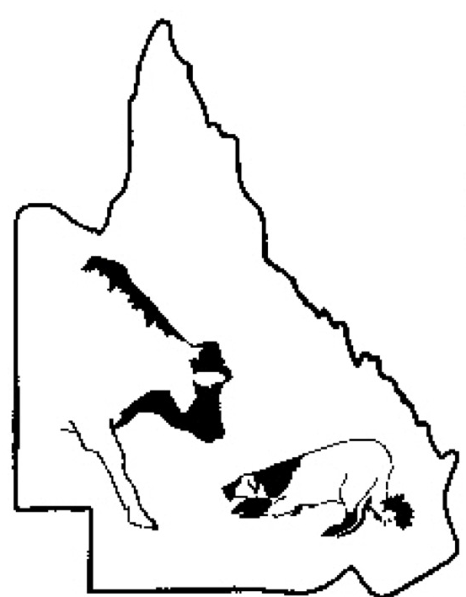
Open: $Nomination
Novice: $Nomination
Maiden: $Nomination
Bush Handler: $Nomination

Contact: Name
Phone: Number
Nominations Close: Date

Catering/Bar Available?
Camping/Power Availability?
Camping/Power Charges?
Cost Per Person:

