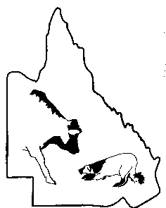
INSERT VENUE HERE Working Cattle Dog Trial
Maiden/Novice Competition
Run # | Handler | Dog | M/N | Novice |  |  |  | Maiden
 |  |  |  | 1st | Final | Total | Place | 1st | Place
INSERT DATE HERE Judge: INSERT JUDGE HERE

INSERT VENUE HERE Working Cattle Dog Trial
Maiden/Novice Competition
Run # | Handler | Dog | M/N | Novice |  |  |  | Maiden
 |  |  |  | 1st | Final | Total | Place | 1st | Place
INSERT DATE HERE Judge: INSERT JUDGE HERE

INSERT VENUE HERE Working Cattle Dog Trial
Maiden/Novice Competition
Run # | Handler | Dog | M/N | Novice |  |  |  | Maiden
 |  |  |  | 1st | Final | Total | Place | 1st | Place
INSERT DATE HERE Judge: INSERT JUDGE HERE

INSERT VENUE HERE Working Cattle Dog Trial
Maiden/Novice Competition
Run # | Handler | Dog | M/N | Novice |  |  |  | Maiden
 |  |  |  | 1st | Final | Total | Place | 1st | Place
INSERT DATE HERE Judge: INSERT JUDGE HERE

